KẾ HOẠCH BÀI DẠY THI GIÁO VIÊN TIỂU HỌC DẠY GIỎI
CẤP THỊ XÃ NĂM HỌC 2022-2023
Họ và tên giáo viên dạy : Nguyễn Thị Quỳnh Yến
Đơn vị công tác : Trường TH Kim Đồng – TX Buôn Hồ
Tên bài : Unit 20: Which one is more exciting, life in the city or life in the countryside? Lesson 3: 1,2,3
Môn : Tiếng Anh Tiết: 3 Lớp: 5a2- Trường Tiểu học Quang Trung- TX Buôn Hồ
Ngày dạy: 10/5/ 2023
I. The aims of the lesson.
1. Knowledge.

By the end of the lesson students will be able to say the sentences with the correct intonation and do the chant

2. Competence
a. General competence:
- Independence and seft-study: Students can read words, the sentences, listen and repeat the sentence with the correct intonation.
- Communicative and collaborative: Students can discuss the information; work in pairs to ask and answer the questions; work in pairs to mark the sentence intonation; work in groups to chant.
- Sloving problems and creative: Students can show teachers and friends about their pronunciation.
b. Specific competence:
- Students can review vocabularies and sentence patterns: Which one is ..., ... or ...? ->I think ...
- Students take part in group works, pair works well.
3. Quality:
- Hard working: Students can take part in activities and tasks in class actively.
- Responsiblities: Students can show their love to their hometown and keep their hometown more beautiful.
II. Teaching equipment and learning materials.
- Teacher prepares the lesson plan, textbooks, pictures, flashcards teaching aids such as personal computers, projectors, speakers…
- Students prepare textbooks, notebooks, studying tools,… ready to the lesson.
III. Teaching process.
1. Activities 1: Warm up (5’)
a) Objective:
- Help students to review Which one is more ..., ... or ...? ->I think ...in order to understand the situation of the new lesson.
- Help students to feel confident and excited.
b) Method: Game : Pass the ball
c) Process:

Teacher's activities | Students' activities
- Guides students how to play the game  - Asks students to play game  - Asks the whole class listen to the song “ Which one is…?”  - Gives comment  - Leads sts to the new lesson. | - Listen to the teacher.  - listen to the song and pass the ball  - Ask and answer the questons: “ Which one is…………, ……or ……?

2. Discovery
*Activity 1: 1. Listen and reapeat (10’)
a) Objective: help students to repeat the sentence with the correct intonation.
b) Method: work individual and work in pairs
c) Process:

Teacher’s activities | Students’ activities
Gets students’ attention by listening to the text twice  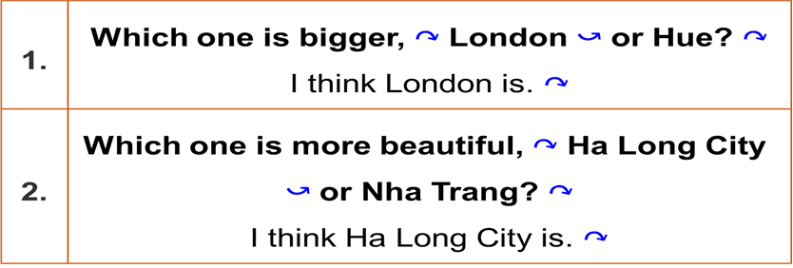  Explains to the student how to raise and lower their voice.  Plays the recording once  Ask sts to work in pairs to practise reading with correct intonation.  Call some ss to read in front of the class.  - T checks and corrects. | Listen  Listen and repeat  Work individually  Work in pairs to practise reading with correct intonation.  Perform with the game “Xì điện”

c) Products: Students can perform their sentence with the correct intonation.

*Activity 2: 2. Listen and mark the sentence intonation. Then say the sentences aloud (10’)
a) Objective: help ss to improve listening skill about marking the sentence intonation .
b) Method : Pair work
c) Process
Teacher’s activities | Students’ activities
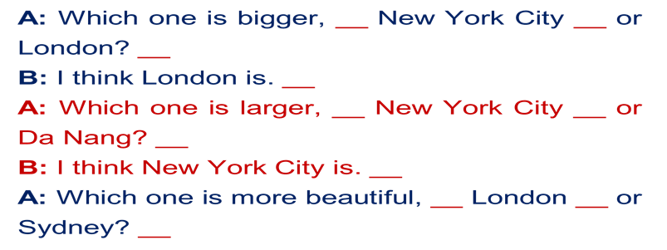  Have ss that they are going to listen and mark the sentence intonation  - Play the recording twice for ss to listen and mark the sentence intonation.  Compare the answer with the partner.  - Play the recording again ss to check their answers.  Gives the answer and feedback  Answers:  1. A: Which one is bigger, ↷ New York City ⤻ or London? ↷  B: I think London is. ↷  2. A: Which one is larger, ↷ New York City ⤻ or Da Nang? ↷  B: I think New York City is. ↷  3. A: Which one is more beautiful, ↷ London ⤻ or Sydney? ↷  B: I think London is. ↷  - Have ss practise saying aloud the sentences in pairs.  -T checks and coreccts their pronunciation.  -T asks sts play the game one to three to practice the sentence then call 2 pairs to perform in front of class.  Give comment | Listen to the teacher’s guide  Listen and mark  10 groups (5-6 students) do the exercise  Give answers on the board  Look and check with the teacher  Read the passage aloud  Exchange the paper with their partner  2 students go to the board and show their answer  Compare the answers with the teacher  Practice reading then perform  Play the game one to three to practice the sentence  Perform in front of class
d) Products: SS can improve listening skill about marking the sentence intonation
*Activities 3: 3. Let’s chant (8’)
a) Objective: help ss practise the chant: Which one is more…?
b) Method: Pair work
c) Process

Teacher’s activities | Students’ activities
Has pupils look at screen  - Introduce the Chant: Which one is more…?  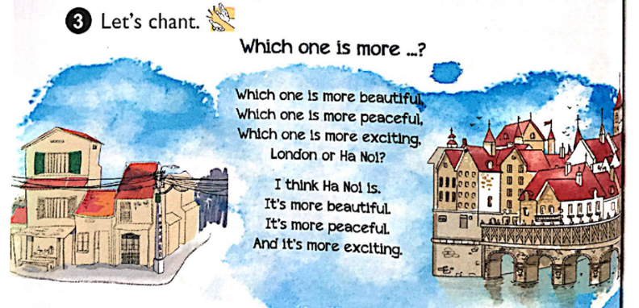  -Play the recording twice for ss to listen  Explains students’ duty  -Have ss read the chant and check their comprehension.  - Have ss listen and repeat the chant line by line  - T models first, then have ss to  Have ss chant and do the chant in chorus,in groups( 3 groups) , in individual work  -Teacher reinforce their pronunciation | Look  Listen  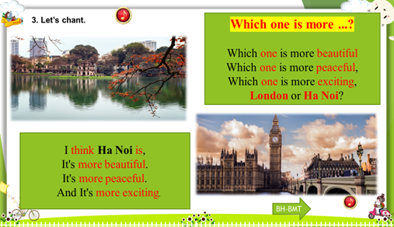  Listen to the chant  Read the sentences in pairs  Practice in pair  Perform ( whole class, in groups, in individual work) in front of the class
d) Products: Students know how to do the chant with the correct rythym.

3. Application and Creation (2’)
a) Objective: students can read the chant with anothers
b) Method : group work, individual
c) Process
Teacher’s activities | Students’ activities
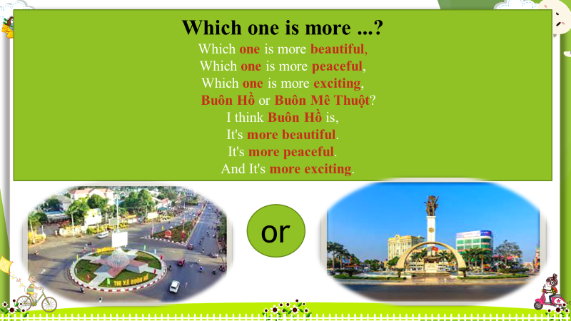  Asks students to replace the chant with Buôn Hồ and Buôn Mê Thuột.  Gives comment and say the love of places of Viet Nam and ask what should they do to express their love to our country.  Gives compliments | Work in class
d) Products: Help students know how to chant correctly and express express their love to our country.

Người thực hiện

Nguyễn Thị Quỳnh Yến

